Lab 4 CCS3104
28 November 2025
- Solve the following questions and demonstrate your solutions to me in this lab, the next lab or at the start of the lab after next. This is a 2-weeks lab. For record-keeping, submit also your solutions and screenshots of their output to PutraBlast.
- Evaluation will be done according to the lab rubric on PutraBlast. I will ask questions accordingly.
*******************************

Questions:

- Answer the following question from the 10th edition Liang textbook:

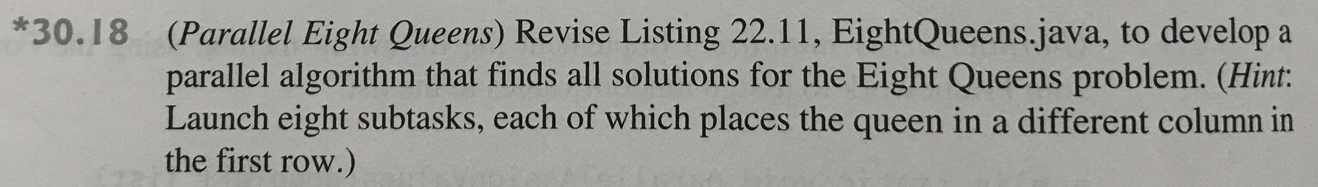

Listing 22.11, EightQueens.java can be obtained from https://liveexample.pearsoncmg.com/html/EightQueens.html. The “queen.jpg” image can be obtained from https://liveexample.pearsoncmg.com/common/image/queen.jpg. An animation of the algorithm is at https://liveexample.pearsoncmg.com/dsanimation/EightQueens.html (not sure how much this helps you but it’s there).

Some context from the textbook regarding the Eight Queens problem is provided in the following pages:
